

**Lab No. 02**

Mehran University of Engineering and Technology Shaheed Zulfiquar Ali Bhutto Campus, Khairpur Mir’s Department of Software Engineering

**Course: Operating System SW-225 (Practical) - Instructor: Engr. Shamshad Naveed**

Objective: To become familiar with the Windows Command Prompt

|  |  |  |  |  |
| --- | --- | --- | --- | --- |
| **Name:** | **Muhammad Saleem** | **Roll Number:** | | **K20SW033** |
| **Score:** | **Signature:** | **Date:** | **08-09-2022** | |

|  |  |  |  |  |  |  |  |
| --- | --- | --- | --- | --- | --- | --- | --- |
| **LAB PERFORMANCE INDICATOR** | SUBJECT KNOWLEDGE | DATA ANALYSIS AND INTERPRETATION | ABILITY TO CONDUCT EXPERIMENT | PRESENTATION | CALCULATION AND CODING | OBSERVATION  /RESULTS | SCORE |
|  |  |  |  |  |  |  |  |

Exercise/Tasks

# Exercise 01

**01. Create a Folder having your RollNo.**

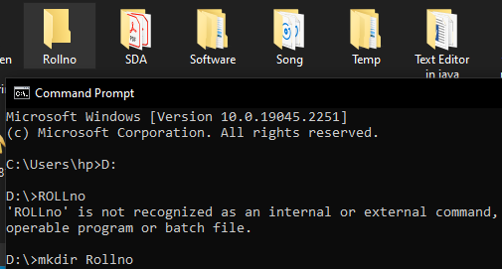

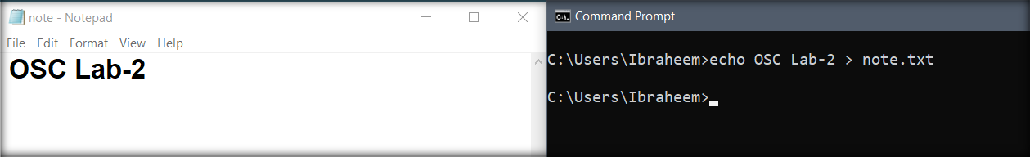

**03.** prompt.Save the file in the folder giving it your name in lower caps

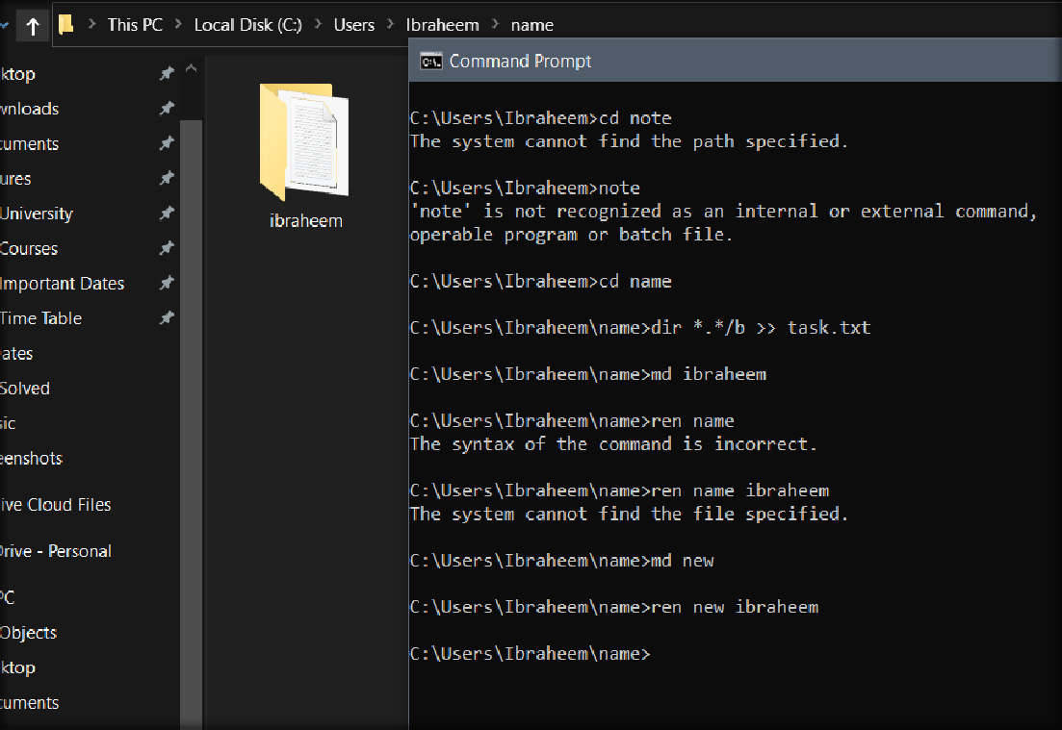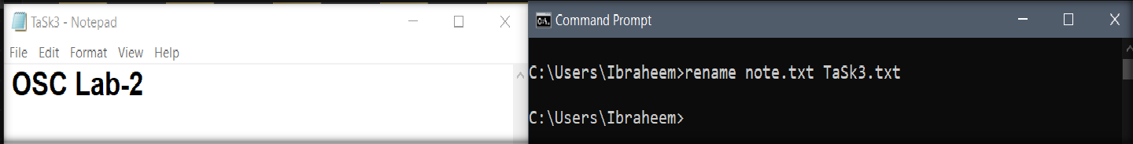

1. Create a sub folder named OSCLab and copy the txt file into that folder

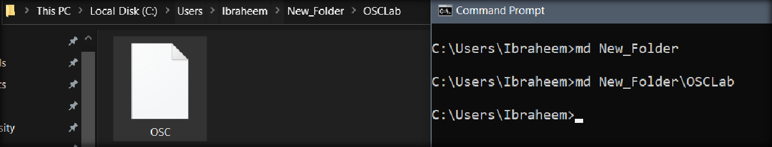

1. Create a backup of that file

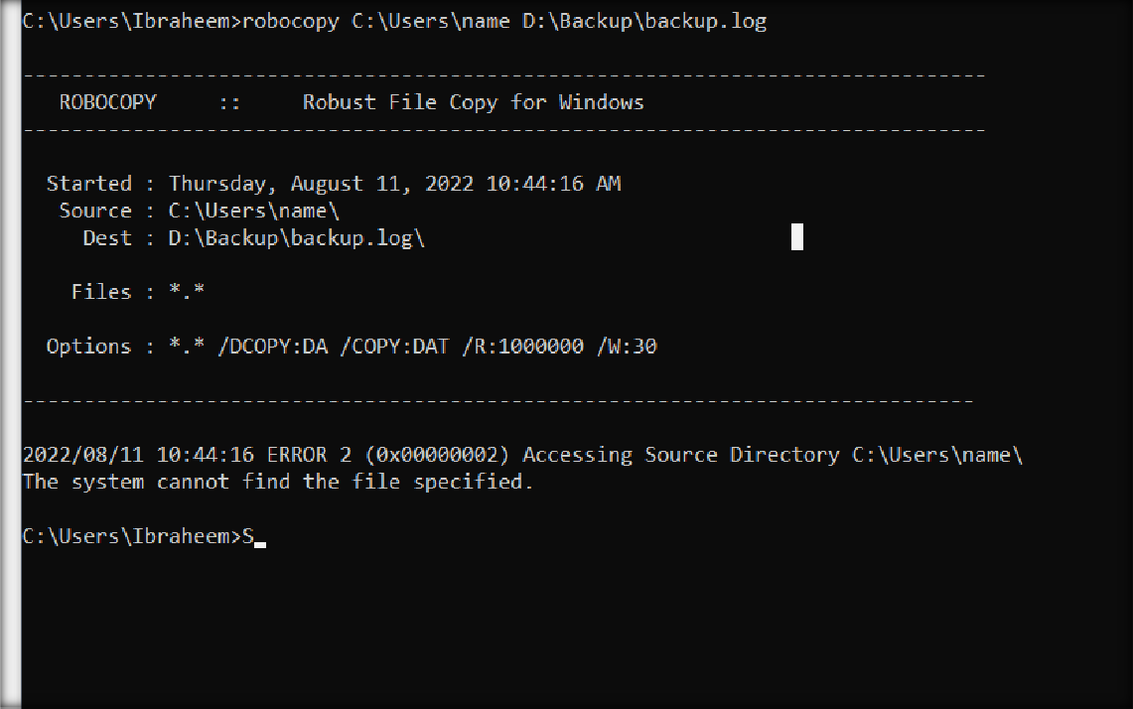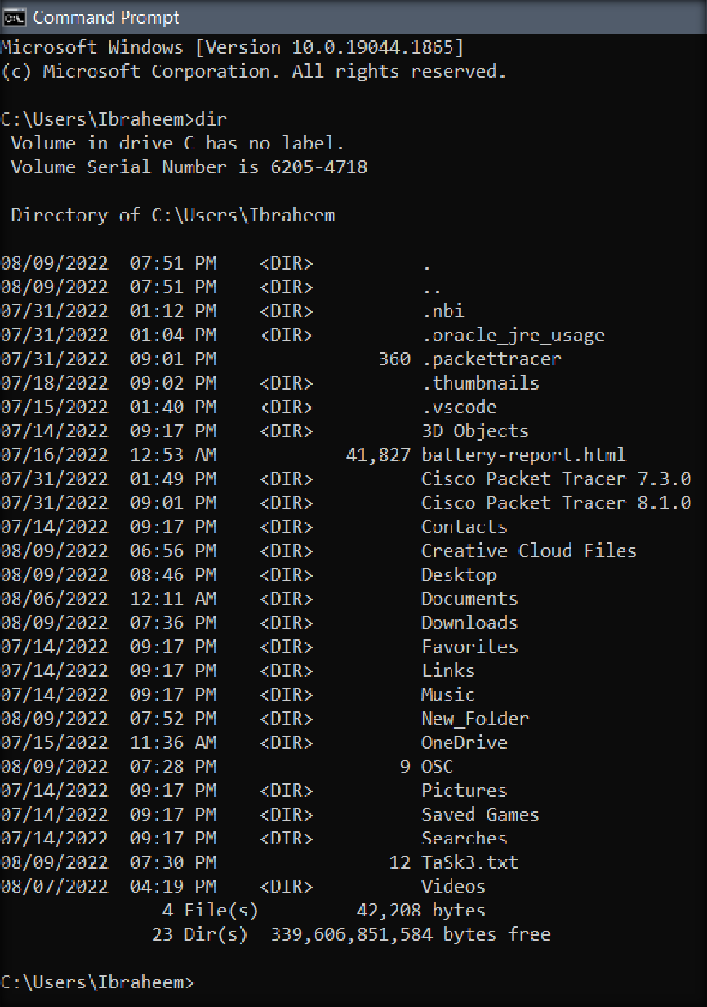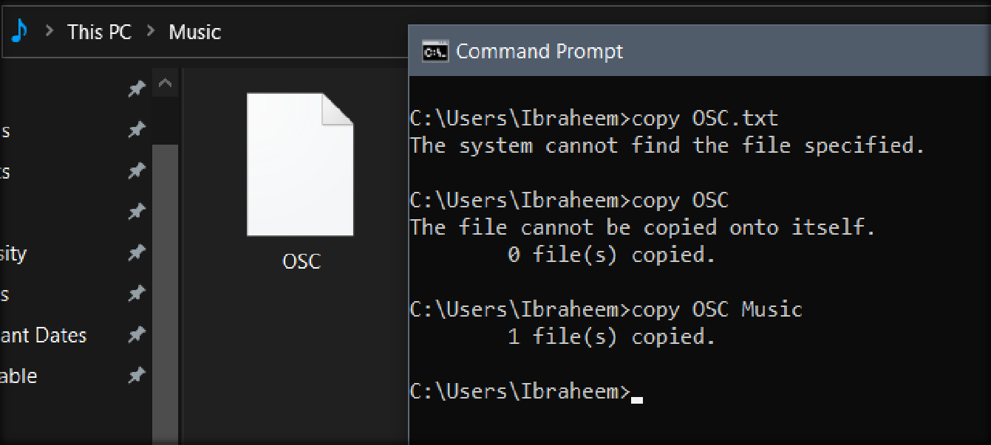

**09.** Open mspaint and create a bmp file, store it in the folder OSCLab

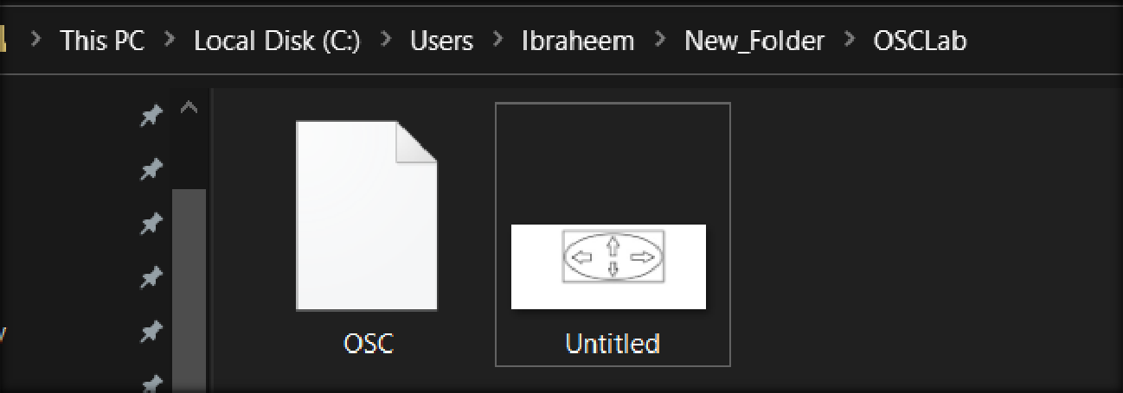

1. Rename that file and copy it outside to the main folder having your RollNo

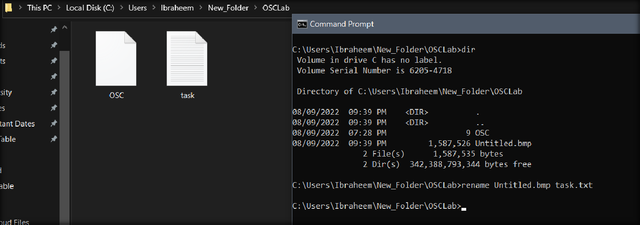

# Exercise 02

* 1. Type help in the command prompt and show the working of any 10 commands in that list. (make sure the commands have not been used in this lab)

# Command 01: “arp”

This command displays, adds, and removes arp information from network devices

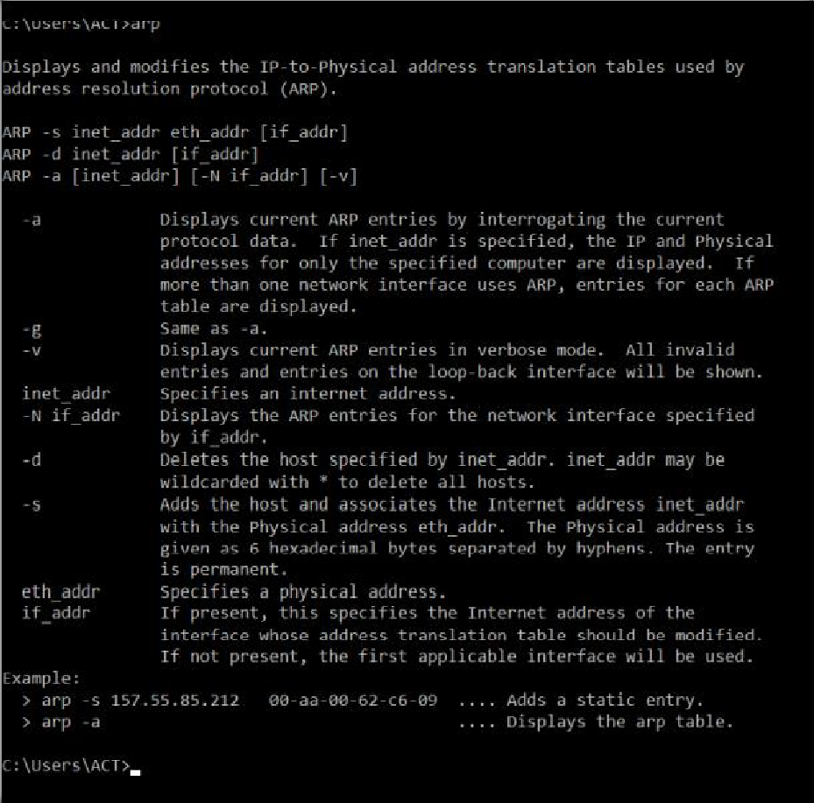

# Command 02: “cacls”

* + - * This command enables a user to view and modify an ACL of a file

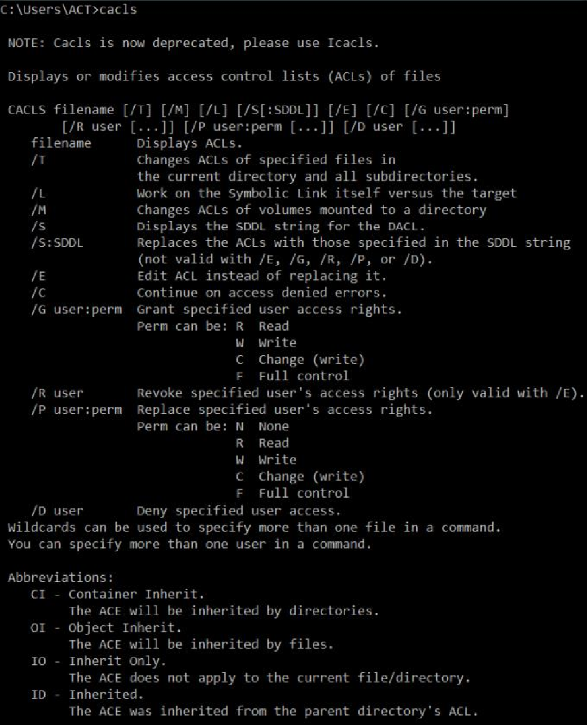

* + 1. **Command 03:**

**“compact”**

The compact command is used to compress files, or uncompress them so that they are viewable

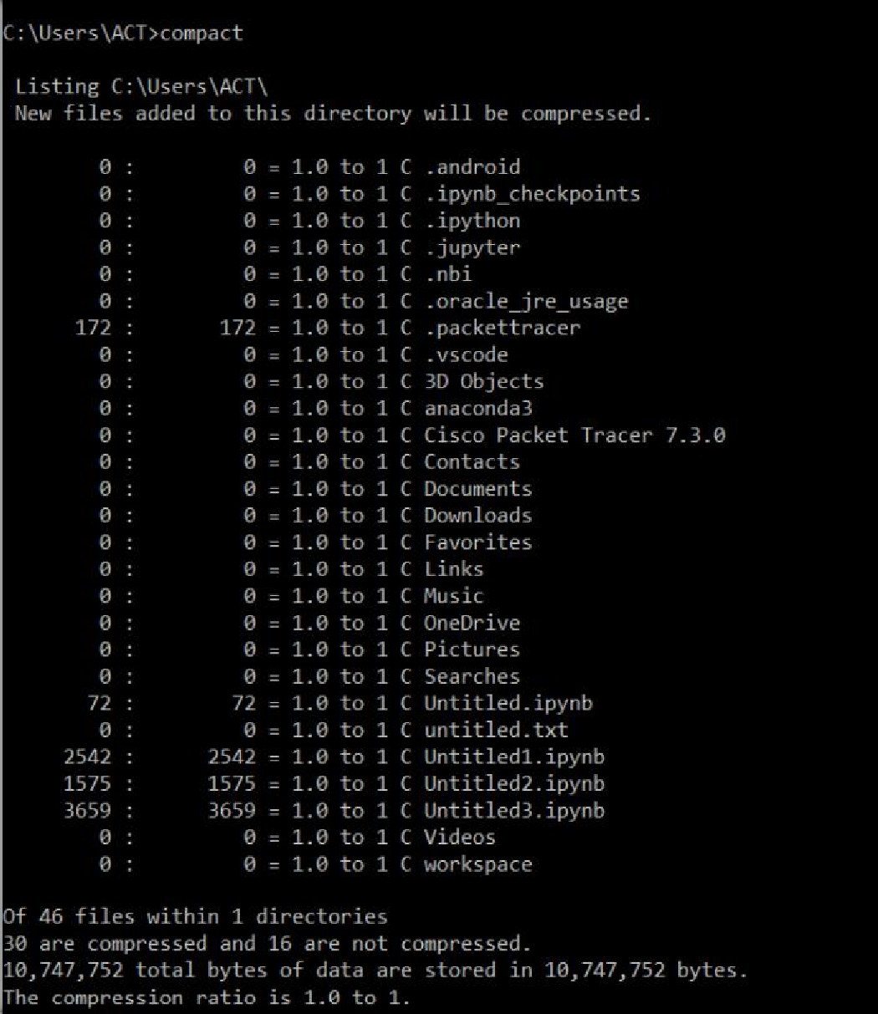

* + 1. **Command 04:**

**“date”**

* + - * The date command can view or change the current date of the system clock

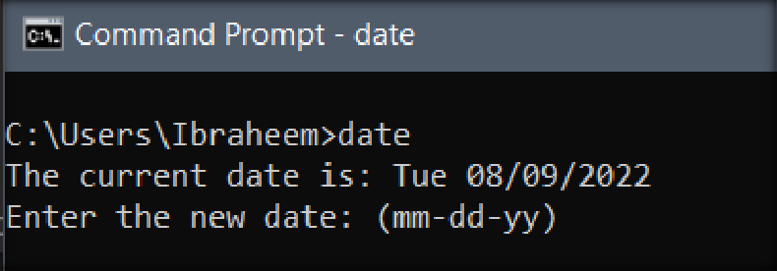

* + 1. **Command 05: “echo”**
       - The echo command repeats typed text back to the screen and can send text to a peripheral on the computer, such as a COM port.

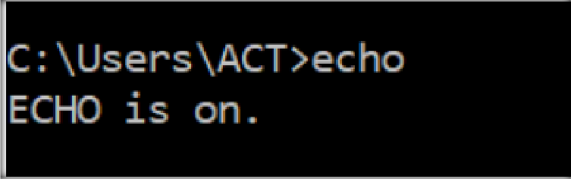

* + 1. **Command 06:**

**“expand”**

The expand command is used to take a compressed Windows file and "expand" it to its original form

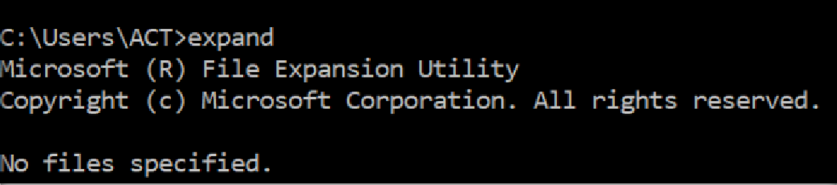

* + 1. **Command 07:**

**“label”**

* + - * The label command is used to view or change the label of a computer's drives

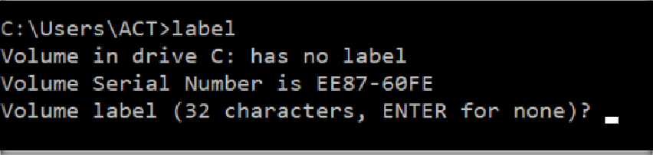

* + 1. **Command 08:**

**“mode”**

The mode command is used to view or modify a port or display setting.

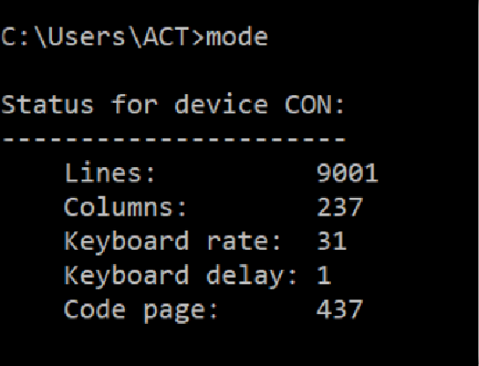

* + 1. **Command 09:**

**“netsh”**

* + - * Netsh is an MS-DOS command that enables users to change network settings.
      * **For example.** users may switch their network device from a dynamic address to a static address or changing the IP address.

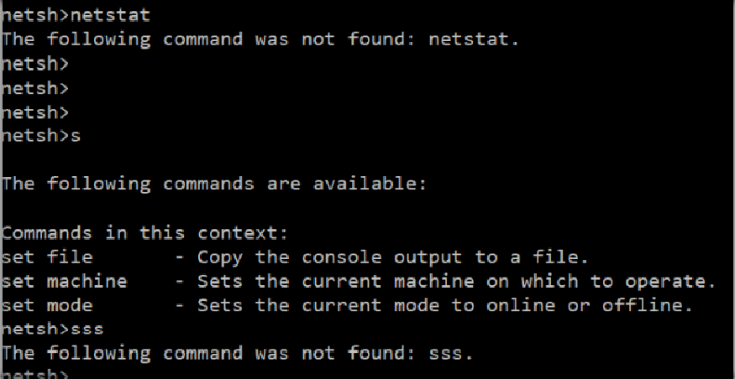

* + 1. **Command 10: “Nslookup”**
       - Nslookup is an MS-DOS utility that enables a user to look up the IP address of a domain or host on a network. The nslookup command can also perform a reverse lookup using an IP address to find the domain or host associated with that IP address

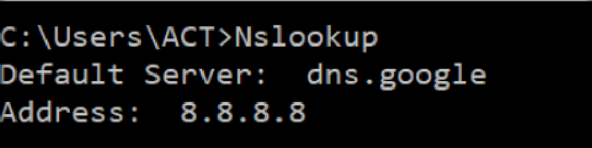

* 1. Type help in the command prompt and show the working of any 10 commands in that list. (make sure the commands have not been used in this lab)

**Task:**

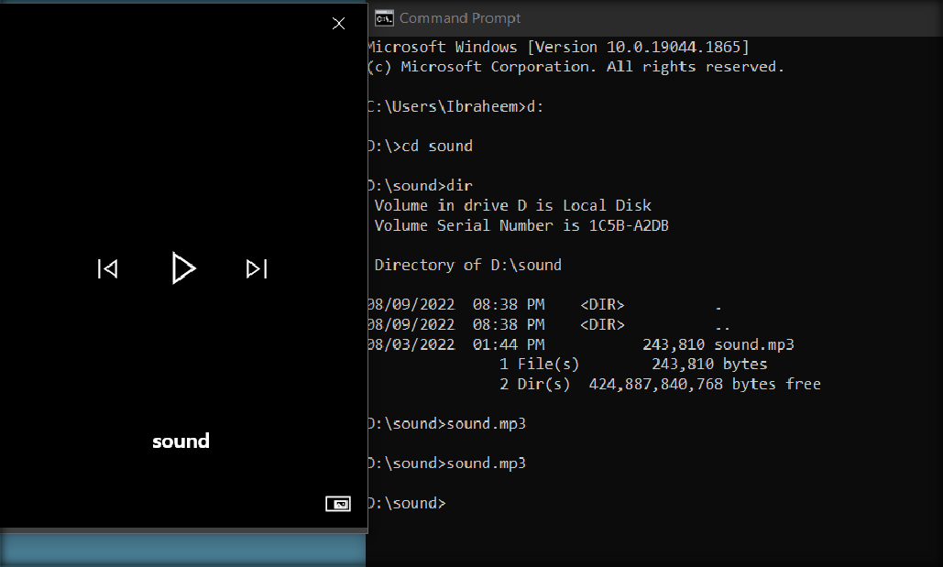

* 1. Write a command to open a .docx file through command prompt

**Task:**

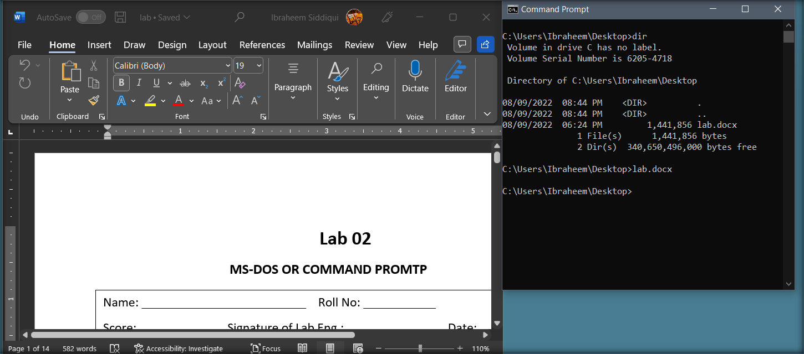

* 1. Write a command to open the following applications

1. **Microsoft Word Task:**

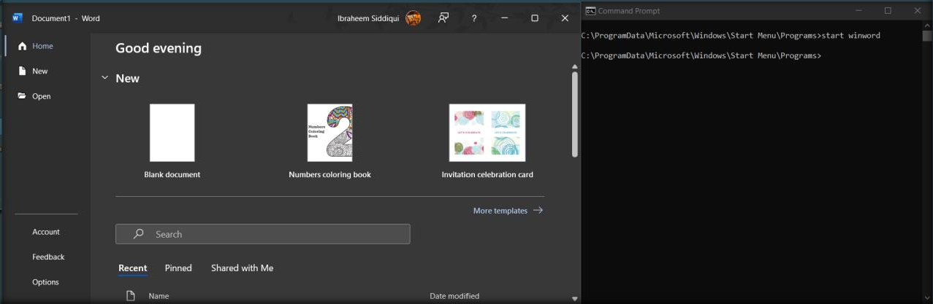

1. Google Chrome or Mozilla FireFox

**Task:**

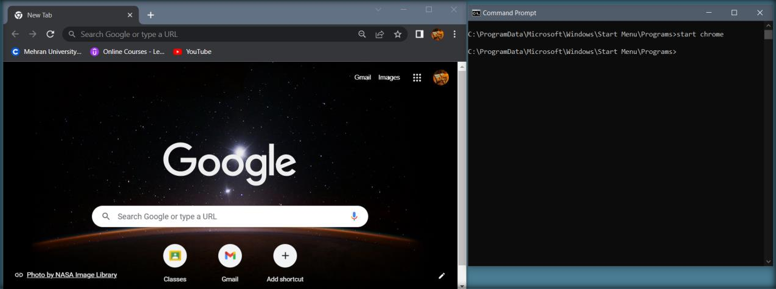

1. **Skype**

**Task:**

